

**FACULTY OF COMPUTING AND INFORMATION TECHNOLOGY**

Diploma in Software Engineering

Programme: _DCS1__ (Group: ___5___)

**Assignment**

## AMCS1003 SOFTWARE ENGINEERING

|  |  |  |  |
| --- | --- | --- | --- |
| **Name (Block Letters)** | **Registration No.** | **Signature** | **Marks** |
| 1. Tan Kang Hong | 2002959 | Tan |  |
| 2. Nee Mei Yi | 2003199 | Myi |  |
| 3. Lau Jun Dian | 2003133 | Dian |  |
| 4. Har Chun Wai | 2002982 | Wai |  |
| 5. Cheng Cai Jie | 2003191 | cheng |  |

Lecturer’s Name: Tan Chi Wee

Date of Submission: 16-4-2021



**FACULTY OF COMPUTING AND INFORMATION TECHNOLOGY**

**Plagiarism Statement and Guideline for Late Submission of Coursework**

Read, complete, and sign this statement to be submitted with the written report.

**We confirm that the submitted works are all our own work and are in our own words.**

|  |  |  |  |
| --- | --- | --- | --- |
| **Name (Block Letters)** | **Registration No.** | **Signature** | **Date** |
| 1. Tan Kang Hong | 2002959 | Tan | 13/4/2021 |
| 2. Nee Mei Yi | 2003199 | Myi | 13/4/2021 |
| 3. Lau Jun Dian | 2003133 | Dian | 13/4/2021 |
| 4. Har Chun Wai | 2002982 | Wai | 13/4/2021 |
| 5. Cheng Cai Jie | 2003191 | cheng | 13/4/2021 |

**AMCS1003 Software Engineering - Group Assignment Rubrics (CLO 1 & CLO2)**

|  |  |  |  |  |  |  |  |  |  |  |  |  |  |  |  |  |  |  |  |  |  |  |  |  |  |
| --- | --- | --- | --- | --- | --- | --- | --- | --- | --- | --- | --- | --- | --- | --- | --- | --- | --- | --- | --- | --- | --- | --- | --- | --- | --- |
| Student Names: | | Tan Kang Hong | | | |  | |  | |  | |  | |  | | Group: 4 | |  | |  | |  | |  | |
|  | | Nee Mei Yi | | | |  | |  | |  | |  | |  | | Programme: DCS1 (G5) | | | |  | |  | |  | |
|  | | Lau Jun Dian | | | |  | |  | |  | |  | |  | |  | |  | | Mark: | |  | |  | |
|  | | Har Chun Wai | | | |  | |  | |  | |  | |  | |  | |  | |  | |  | |  | |
|  | | Cheng Cai Jie | | | |  | |  | |  | |  | |  | |  | |  | |  | |  | |  | |
|  | |  | |  | |  | |  | |  | |  | |  | |  | |  | |  | |  | |  | |
| **Section** | | **Criteria / Area** | | **Excellent** | | | | **Good** | | | | **Average** | | | | **Poor** | | | | **Very Poor** | | | | **Score** | |
| **Part 1** | | **Problems of**  **existing/legacy system** | | Very good description on the chosen existing system and elaboration on problems of existing/ legacy system. | | (5m) | | Good description on the chosen existing system and elaboration on existing system problems of existing/ legacy system. | | (4m) | | Generally show attempt on providing description on the chosen existing system and elaboration on existing system problems of existing/ legacy system. | | (3m) | | Little attempt to provide description on the chosen existing system and elaboration on existing system problems of existing/ legacy system. | | (2m) | | Very little attempt to provide description on the chosen existing system and elaboration on existing system problems of existing/ legacy system. | | (1m) | |  | |
| **Softw are quality attributes** | | Very good explanation on suggested  softw are quality attributes for the proposed system scenario. | | (8-10m) | | Good explanation on suggested softw are quality attributes for the  proposed system scenario. | | (5-7m) | | Generally show attempt to provide explanation on suggested softw are quality attributes for the proposed system scenario. | | (3-4m) | | Little attempt to provide explanation on suggested  softw are quality attributes for the proposed system scenario. | | (2m) | | Very little attempt to provide explanation. Irrelevant softw are quality attributes. | | (1m) | |  | |
| **Suggested Softw are**  **Process Model** | | Very good justification and elaboration on  suggested process model. | | (8-10m) | | Good justification and elaboration on suggested process model. | | (5-7m) | | Generally good on providing justification and elaboration on suggested process model. | | (3-4m) | | Little attempt to provide justification and elaboration on suggested process model. | | (2m) | | Very little attempt to provide justification and elaboration on suggested process model. | | (1m) | |  | |
| **TOTAL (25 marks)** | | | | | | | | | | | | | | | | | | | | | | | |  | |
| **Section** | | **Criteria / Area** | | **Excellent** | |  | | **Good** | |  | | **Average** | |  | | **Poor** | |  | | **Very Poor** | |  | | **Score** | |
| **Part 2** | | **Project Plan and Schedule** | | Very good project plan and schedule for the project  scenario & process model chosen. | | (8-10m) | | Good project plan and schedule for the project scenario & process model chosen. | | (5-7m) | | Show s attempt in producing project plan and schedule. | | (3-4m) | | Inadequate attempt to prepare project plan. . | | (2m) | | Very little attempt to develop project plan. | | (1m) | |  | |
| **Softw are**  **Requirement Specification (SRS)** | | Very good SRS w ith w ell defined, structured and organised requirements for the new system. | | (13- 15m) | | Good SRS w ith good defined, structured and organised requirements for the new system. | | (10- 12m) | | Good on identifying the requirements for the new system but some errors. | | (7-9m) | | Inadequate attempt to identify the requirements for the new system. | | (5-8m) | | Very little attempt to identify the requirements for the new system. | | (1-4m) | |  | |
| **Suggested System**  **Organisation Model.** | | Very good elaboration on the suggested system organisation model. | | (8-10m) | | Good elaboration on the suggested system organisation model. | | (5-7m) | | Generally good on providing elaboration on the suggested system organisation model. | | (3-4m) | | Little attempt to provide elaboration on the suggested system organisation model. | | (2m) | | Very little attempt to provide elaboration on the suggested system organisation model. | | (1m) | |  | |
| **TOTAL (35 marks)** | | | | | | | | | | | | | | | | | | | | | | | |  | |

|  |  |  |  |  |  |  |  |  |  |  |  |  |
| --- | --- | --- | --- | --- | --- | --- | --- | --- | --- | --- | --- | --- |
| **Section** | **Criteria / Area** | **Excellent** |  | **Good** |  | **Average** |  | **Poor** |  | **Very Poor** |  | **Score** |
| **Part 3** | **Test Cases** | Very good structured and organised test case. Very good on elaboration. | (5m) | Good on developing test case. Organised and good on elaboration. | (4m) | Generally good on developing test case but lack elaboration. | (3m) | Inadequate attempt to develop test case. Lack elaboration. | (2m) | Very little attempt to develop test case. | (1m) |  |
| **Screen Design Principles** | Very good elaboration of UI design principles/guideline s used & excellent match w ith the screen design developed. | (8-10m) | Good elaboration of UI design principles/guideline s used & good match w ith the screen design developed. | (5-7m) | Generally show attempt on suggesting UI design principles/guidelines but lack of match w ith the screen design developed. | (3-4m) | Poor elaboration on UI design principles/guideline s used and lack of match w ith the screen design developed. | (2m) | Very poor elaboration on UI design principles/guidelines used & totally not match w ith the screen design developed. | (1m) |  |
| **Softw are**  **Maintenance** | Very good description on the maintenance that can be provided for the new system. | (8-10m) | Good description on the maintenance that can be provided for the new system. | (4m) | Generally show attempt on providing description on the maintenance that can be provided for the new system. | (3m) | Little attempt to description on the maintenance that can be provided for the new system. | (2m) | Very little attempt to provide description on the maintenance that can be provided for the new system. | (1m) |  |
| **TOTAL (20 marks)** | | | | | | | | | | | |  |

**AMCS1003 Software Engineering - Individual Assignment Rubric (CLO3)**

|  |  |  |  |  |  |  |  |  |  |  |  |  |  |  |  |  |  |  |  |  |  |  |  |  |  |  |  |  |  |  |  |  |  |  |  |  |  |  |  |  |  |  |  |  |  |  |  |  |  |  |  |  |  |  |  |  |  |  |
| --- | --- | --- | --- | --- | --- | --- | --- | --- | --- | --- | --- | --- | --- | --- | --- | --- | --- | --- | --- | --- | --- | --- | --- | --- | --- | --- | --- | --- | --- | --- | --- | --- | --- | --- | --- | --- | --- | --- | --- | --- | --- | --- | --- | --- | --- | --- | --- | --- | --- | --- | --- | --- | --- | --- | --- | --- | --- | --- |
| Programme: D | | Student Names: |  | (1) | Tan Kang Hong | | | | | | | |  |  | (2) | Nee Mei Yi | | | | | | | |  |  | (3) | Lau Jun Dian | | | | | | | |  |  | (4) | Har Chun Wai | | | | | | | |  |  | (5) | Cheng Cai Jie | | | | | | | |  |  |
| Group: |  |  | mark | |  |  |  |  |  |  |  |  |  | mark | |  |  |  |  |  |  |  |  |  | mark | |  |  |  |  |  |  |  |  |  | mark | |  |  |  |  |  |  |  |  |  | mark | |  |  |  |  |  |  |  |  |  |  |
|  |  |  |  |  |  |  |  |  |  |  |  |  |  |  |  |  |  |  |  |  |  |  |  |  |  |  |  |  |  |  |  |  |  |  |  |  |  |  |  |  |  |  |  |  |  |  |  |  |  |  |  |  |  |  |  |  |  |  |
|  |  |  | Rating: 1-Very Poor, 2-Poor, | | | | | | | | | |  | Rating: 1-Very Poor, 2-Poor, | | | | | | | | | |  | Rating: 1-Very Poor, 2-Poor, | | | | | | | | | |  | Rating: 1-Very Poor, 2-Poor, | | | | | | | | | |  | Rating: 1-Very Poor, 2-Poor, | | | | | | | | | |  | **Excellent** |
| **Section** | **Criteria/Area** | **Very Poor** | 3-Average, 4-Good, 5-Excellent | | | | | | | | | |  | 3-Average, 4-Good, 5-Excellent | | | | | | | | | | | 3-Average, 4-Good, 5-Excellent | | | | | | | | | |  | 3-Average, 4-Good, 5-Excellent | | | | | | | | | |  | 3-Average, 4-Good, 5-Excellent | | | | | | | | | |  |
| **Oral**  **Presentation** | Ability to deliver ideas clearly and confidently. | Delivery of ideas is vague without confidence. |  | 1 |  | 2 |  | 3 |  | 4 |  | 5 |  |  | 1 |  | 2 |  | 3 |  | 4 |  | 5 |  |  | 1 |  | 2 |  | 3 |  | 4 |  | 5 |  |  | 1 |  | 2 |  | 3 |  | 4 |  | 5 |  |  | 1 |  | 2 |  | 3 |  | 4 |  | 5 |  | Able to present ideas very clearly, attractively and confidently. |
|  |  |  |  |  |  |  |  |  |  |  |  |  |  |  |  |  |  |  |  |  |  |  |  |  |  |  |  |  |  |  |  |  |  |  |  |  |  |  |  |  |  |  |  |  |  |  |  |  |  |  |  |  |  |  |
|  |  |  |  |  |  |  |  |  |  |  |  |  |  |  |  |  |  |  |  |  |  |  |  |  |  |  |  |  |  |  |  |  |  |  |  |  |  |  |  |  |  |  |  |  |  |  |  |  |  |  |  |  |  |  |
| Ability to deliver an organized sequence of information. | Unable to deliver an organized sequence of information. |  | 1 |  | 2 |  | 3 |  | 4 |  | 5 |  |  | 1 |  | 2 |  | 3 |  | 4 |  | 5 |  |  | 1 |  | 2 |  | 3 |  | 4 |  | 5 |  |  | 1 |  | 2 |  | 3 |  | 4 |  | 5 |  |  | 1 |  | 2 |  | 3 |  | 4 |  | 5 |  | Able to deliver very organized sequence of information. |
|  |  |  |  |  |  |  |  |  |  |  |  |  |  |  |  |  |  |  |  |  |  |  |  |  |  |  |  |  |  |  |  |  |  |  |  |  |  |  |  |  |  |  |  |  |  |  |  |  |  |  |  |  |  |  |
|  |  |  |  |  |  |  |  |  |  |  |  |  |  |  |  |  |  |  |  |  |  |  |  |  |  |  |  |  |  |  |  |  |  |  |  |  |  |  |  |  |  |  |  |  |  |  |  |  |  |  |  |  |  |  |
| Presentation skill | Inaudible, no eye contact, speaker seemed uninterested and used monotone |  | 1 |  | 2 |  | 3 |  | 4 |  | 5 |  |  | 1 |  | 2 |  | 3 |  | 4 |  | 5 |  |  | 1 |  | 2 |  | 3 |  | 4 |  | 5 |  |  | 1 |  | 2 |  | 3 |  | 4 |  | 5 |  |  | 1 |  | 2 |  | 3 |  | 4 |  | 5 |  | Poised, clear articulation; proper volume; steady rate; good posture and eye contact; enthusiasm; |
|  |  |  |  |  |  |  |  |  |  |  |  |  |  |  |  |  |  |  |  |  |  |  |  |  |  |  |  |  |  |  |  |  |  |  |  |  |  |  |  |  |  |  |  |  |  |  |  |  |  |  |  |  |  |  |
|  |  |  |  |  |  |  |  |  |  |  |  |  |  |  |  |  |  |  |  |  |  |  |  |  |  |  |  |  |  |  |  |  |  |  |  |  |  |  |  |  |  |  |  |  |  |  |  |  |  |  |  |  |  |  |
| Able to use of visual aids and tools for  effective presentation | Not prepare presentation slides and no visual aids used |  | 1 |  | 2 |  | 3 |  | 4 |  | 5 |  |  | 1 |  | 2 |  | 3 |  | 4 |  | 5 |  |  | 1 |  | 2 |  | 3 |  | 4 |  | 5 |  |  | 1 |  | 2 |  | 3 |  | 4 |  | 5 |  |  | 1 |  | 2 |  | 3 |  | 4 |  | 5 |  | Able to of visual aids or tools appropriately and attractively. |
|  |  |  |  |  |  |  |  |  |  |  |  |  |  |  |  |  |  |  |  |  |  |  |  |  |  |  |  |  |  |  |  |  |  |  |  |  |  |  |  |  |  |  |  |  |  |  |  |  |  |  |  |  |  |  |
|  |  |  |  |  |  |  |  |  |  |  |  |  |  |  |  |  |  |  |  |  |  |  |  |  |  |  |  |  |  |  |  |  |  |  |  |  |  |  |  |  |  |  |  |  |  |  |  |  |  |  |  |  |  |  |
|  |  |  |  |  |  |  |  |  |  |  |  |  |  |  |  |  |  |  |  |  |  |  |  |  |  |  |  |  |  |  |  |  |  |  |  |  |  |  |  |  |  |  |  |  |  |  |  |  |  |  |  |  |  |  |  |  |  |  |
|  | Score | Total |  |  |  |  | | | | |  |  |  |  |  |  |  | | | | |  |  |  |  |  |  |  | | | | |  |  |  |  |  |  |  | | | | |  |  |  |  |  |  |  | | | | |  |  |  |  |
|  |  |  |  |  |  |  |  |  |  |  |  |  |  |  |  |  |  |  |  |  |  |  |  |  |  |  |  |  |  |  |  |  |  |  |  |  |  |  |  |  |  |  |  |  |  |  |  |  |  |  |  |  |  |  |  |  |  |  |
|  | **Comments:** | |  | | | | | | | | | | |  | | | | | | | | | | |  | | | | | | | | | | |  | | | | | | | | | | |  | | | | | | | | | | |  |

# **Table of Contents**

|  |  |
| --- | --- |
| **Content** | **Page** |
| **Table of Contents** | **7** |
| **Part 1** | **8** |
| 1.1 Introduction | 8 |
| 1.2 Problems of Existing System | 9 |
| 1.3 Software Quality attributes of the project | 10 – 11 |
| 1.4 Software Process Model – RAD model | 12 – 16 |
| **Part 2** | **17** |
| 2.1 Project Plan and Schedule | 17 |
| 2.2 Software Requirement Specification | 17 – 23 |
| 2.3 Architectural design | 24 – 25 |
| **Part 3** | **26** |
| 3.1 Good user interface design principles | 26 – 30 |
| 3.2 Test cases | 31 – 36 |
| 3.3 Software Maintenance | 37 – 38 |
| **References** | **39 – 41** |

# **Part 1**

## 1.1 Introduction

J&T Express is an Indonesian logistics company. Founded in 2015, the company is generally engaged in logistics and package delivery. J&T uses automated sorting warehouses in Indonesia and Singapore. It received Indonesian Top Brand Award in 2018 and 2019. As of June 2017, it was valued at 543 million dollars.

J&T Express provide fast pick-ups and delivery services. J&T Express's tagline "Express Your Online Business" positions brand as the core of e-commerce express. Their sustainability in implementing advanced IT management system improves the world express delivery services and customer service qualities with fastest, most convenient and efferent claims. As of now, the J&T Express currently has more than 4000 offices, 3000-drop point, 200 gateways with large distribution equipment and more than 50 000 employees.

## 1.2 Problems of Existing System

* Human error.

In terms of logistics, manual analysis and coordination by employees are very time-consuming and laborious tasks, so certain amount of human error is prone to occur. This may cause delays on the delivery of the package. However, the software solution can process data without errors and can operate without delay.

* Lack of automation function.

In case of functions such as creating transportation routes, loading plans, and assigning goods to carriers were operated manually, some errors made by the employees may occur, this may affect the image of the company and also the customer’s experience.

* Delivery information

Customer hard to find their delivery information at all times. Customers want to be able to know the delivery location completely transparently at all times. Provide 24-hour customer service to reduce customer errors caused by transportation.

## 1.3 Software Quality attributes of the project

* Efficiency

The performance shows the capability of the system in the form of responsiveness to certain operations within a specified time to measure in term of the time required to complete the task given by the system. If the system is using all the available resources, the user will get degraded performance failing the system for efficiency. The efficiency is mainly responsible for the system to continue operating within a predetermined time. A good performance of the system can reduce human error as well as reduce the dependence on manpower and the items can be delivered within the agreed time. The system with a great performance could also contribute in increasing overall sales. We can deal with systematically to improve the efficiency of company and reduce the loss caused by human error.

* Reliability

Reliability is the most important property of the system. A system also can measure if the product is reliable enough to sustain in any condition. A system which has a quality of being trustworthy could efficiently prevent some accidents, and reduce the chance of items cannot be delivered. In this way, the company can continue to make profits under stable conditions. Besides, the system can be seen as reliable if the system test produces a low error rate. Lastly, we can use different environments and different conditions to verify product reliability.

* Maintainability

Different products should be easy and effortless to maintain. The system shall be uncomplicated to add codes to the existing system, so that the new features and mechanics can be applied to the system anytime. The system maintenance should be cost-effective, so that it is easy to correct errors or bugs or make some changes to the software. Packaging of components such that they can be repaired through remove and replace actions rather than on-board repair.

* Integrity

Security is responsible for prevent unwarranted access to system functions as well as defend the privacy of data entered into the system. A system with a good security can keep the customer’s items as much as possible and deliver it to the destination safely. At the same time, an insurance plan is provided to improve the safety of items. Security is responsible for the system's ability to reduce the possibility of malicious or accidental behavior and the possibility of information being stolen or lost.

## 1.4 Software Process Model – RAD model

The Rapid Application Development model (or RAD model) is a development model that prioritizes rapid prototyping and rapid feedback in a long development and testing cycle. Through rapid application development, developers can quickly iterate and update software multiple times without having to start the development schedule from scratch each time. The RAD model was firstly proposed in the 1980s by IBM, so it’s definitely nothing new. But unlike the waterfall model, it is not single. According to the requirements of a specific time, this is the continuous development of the development concept. Initially, rapid application development took the form of a spiral model, where one or more development models are used for specific projects. Though the RAD model appeared during the 1980s, it has evolved ever since. It adapted to the needs of the time, while retaining some core development guidelines.

### **1.4.1 Justification**

The RAD model is the most appropriate process model for the proposed system is because it is used to build a product that can be modularized in 2 or 3 months, which is faster compared to other process models.

Compared with other software process models, the RAD model is relatively cheap, but in some cases, it could be expensive. Hiring talented software developers means you need to give them an appropriate salary. On the bright side, if you have them, you can go from idea to final product idea faster than other models.

If the deadline is tight, the RAD model is the best option. If you are under pressure to deliver a workable product, then choosing the RAD platform may be the best choice. If you do not have time for lengthy requirements planning and design phases, then rapid application development software is your best choice. Rapid application development uses a dynamic approach, which makes sense for rapid development because it can change direction quickly.

### **1.4.2 Advantages of RAD model**

* It is useful when you have to reduce the overall project risk

Although most of the RAD model focuses on speed and user involvement of RAD done correctly by risk reduction. The RAD model can focus on the key risk factors in advance and adjust to them based on reliable evidence collected in the early part of the process.

* Quicker delivery and high quality

The RAD model involves highly skilled and efficient developers, as a result the project can be finished on time and a quicker delivery could be possible. These developers also ensure a better quality on the product by involving users in the whole life cycle. Users can review each prototype used during the process which helps in identify any issues.

* Flexible and adaptable to changes

The RAD model makes it easier for users to suggest some changes to be made before the final product. The product can adapt quickly to problems and opportunities, and also can change requirements at any time throughout the process.

### **1.4.3 Disadvantages of RAD model**

* Too dependent on highly skilled developers

The personnel involved in the RAD project are too dependent, and even one of them cannot fully perform the task, which may affect product development.

* Needs user requirement throughout the life cycle of the product

Because the RAD process involves customers from the beginning of the product life cycle. If there are no customers available or quick decisions cannot be made at important decision moments, it may affect the quality and speed of product development.

* Needs strong team collaboration

The RAD process encourages a small team (approximately 2 to 6 developers). At the same time, the developed products require high quality and high speed. To achieve this goal, all members of the team must be very proficient and familiar with the tools used, which is crucial.

### **1.4.4 Phases of RAD model**

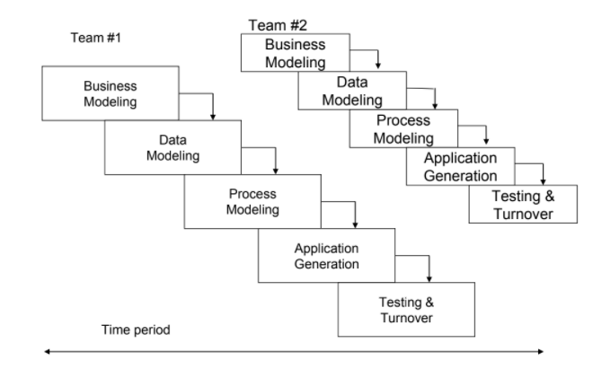

Diagram 1.1 Phases of RAD model

Phase 1: Business modeling

The business modeling step in the RAD model obtains information from company information collected through many business-related sources. This information is then combined into a useful description to explain how the data is used when processing the data, and the reasons for the success of that particular information in the industry. During this phase, it is possible to get a complete picture of business process functionality. Some of the common deliverables are produced in this phase including project definition, project management procedures, and work plan.

Phase 2: Data modeling

In the data modeling phase, all the information collected in the business modeling phase will be analyzed. Through analysis, information can be divided into different groups, which is useful for companies. The quality of each data group has been carefully checked and an accurate description is given. At this stage of the RAD model, the relationship between these groups and their usefulness will also be defined in the business modeling step. These models are used to aid logistics managers in their attempts to design system to cope with the future. In some situations, exact classification of individual model along these two dimensions can be difficult.

Phase 3: Process modeling

The process modeling stage is a step in the RAD modeling process, where all the information groups collected in the data modeling step will be converted into the required usable information. In the process modeling stage, changes and optimizations can be made, and the data set can be further defined. At this stage, any descriptions about adding, deleting or changing data objects will also be created.

Phase 4: Application generation

The "application generation" step is to encode all the information collected and then build the system that will be used to create the prototype. The created data model will be transformed into an actual prototype, which can be tested in the next step.

Phase 5: Testing and Turnaround

The testing and turnaround phase can reduce the overall test time for creating a prototype. Each model is individually tested to quickly identify and adjust components to create the most effective product. Since most of the elements have been checked before, there should be no major issues with the prototype.

# **Part 2**

## 2.1 Project Plan and Schedule

Task Allocation list and Gantt Chart are available in Excel File:

<https://onedrive.live.com/view.aspx?resid=3074BFCAF65A538B!11798&ithint=file%2cxlsx&authkey=!AJFGhS7gZlP4MK8>

## 2.2 Software Requirement Specification

### **2.2.1 Functional requirements**

#### **Customer**

1. The system should allow customers to register their J&T ID before they can access to member-only contents in the J&T Express’s website or mobile app.

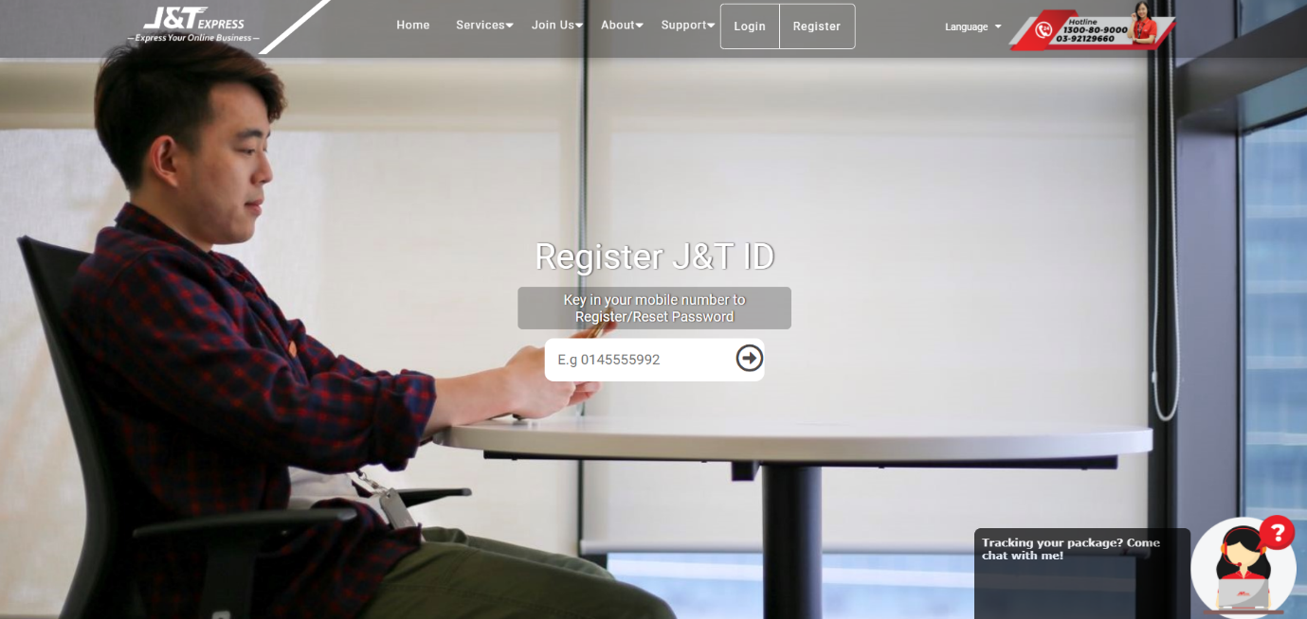

Diagram 2.2.1.1 The register screen which needs customer to input the phone number

2. The system should allow customers to login with their username, e-mail or phone number and the password when the customer wants to access ...

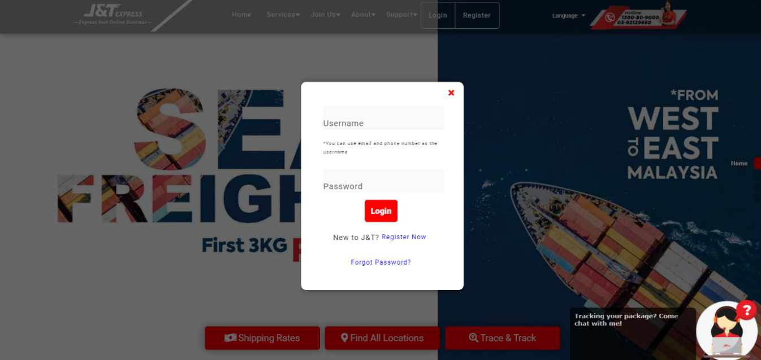

Diagram 2.2.1.2 Login screen

3. The system should display the order page so it can allow customers to place their order when they want to create an order.

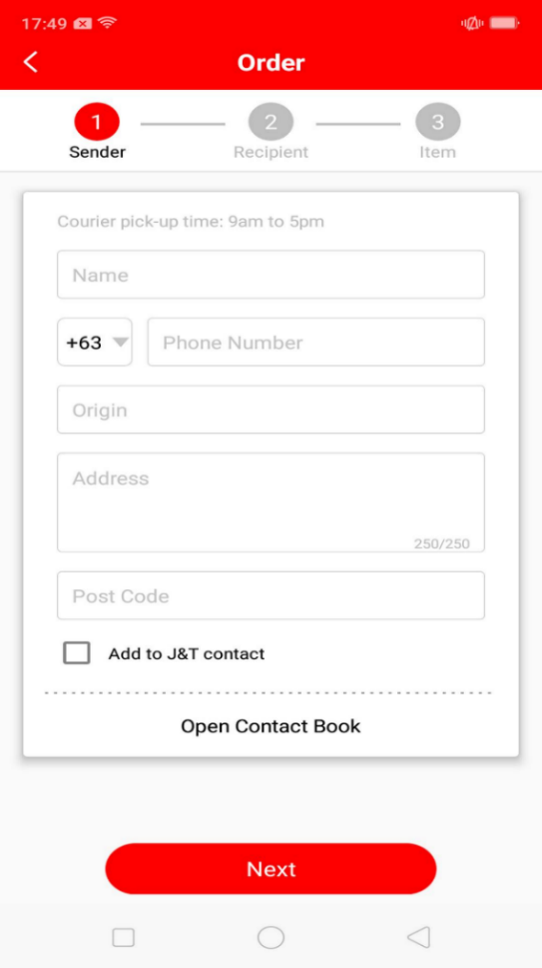

Diagram 2.2.1.3 A create order screen in the mobile app

4. The system will display the order details and prompts the customer to confirm the amount before they start to make payment.

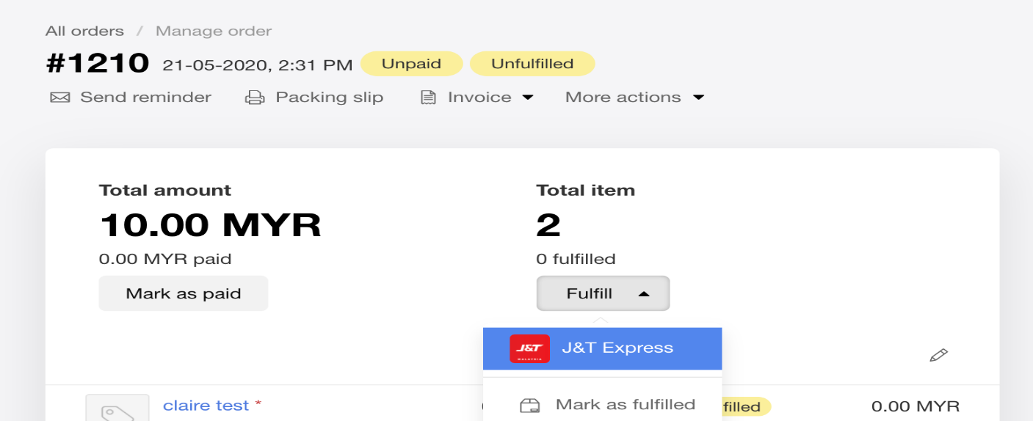

Diagram 2.2.1.4 An order payment screen in the website

5. The system will send the customer the verification email to confirm that they have ordered it by them self when they want to make a payment.

6. The system will generate a receipt to the customer via e-mail after the order have successfully done by the customer.

7. The system should allow customers to check the estimated delivery time provided when the customer’s order is sent for delivery.

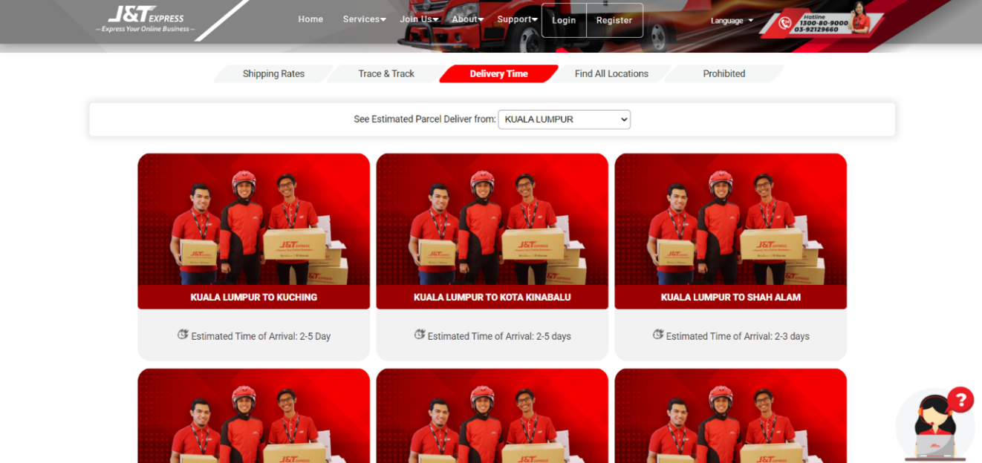

Diagram 2.2.1.5 The screen of the estimated delivery time from Kuala Lumpur

8. The system should allow customers to trace and track their order by typing their airwaybill number when the customer’s order has been shipped.

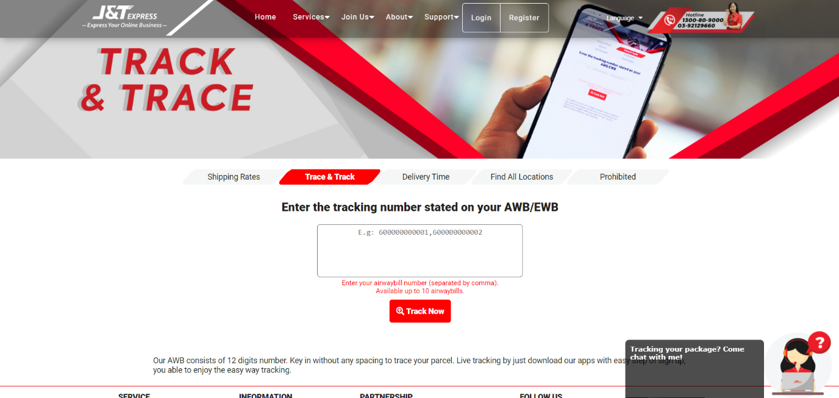

Diagram 2.2.1.6 Trace and Track screen

9. The System should send an e-mail to the customer to remind them that the parcel has arrived at its nearest J&T branch and is ready for delivery.

10. The system should allow the customers to send feedback about the J&T Express via contacting the service so the company can have the opportunity to improve it.

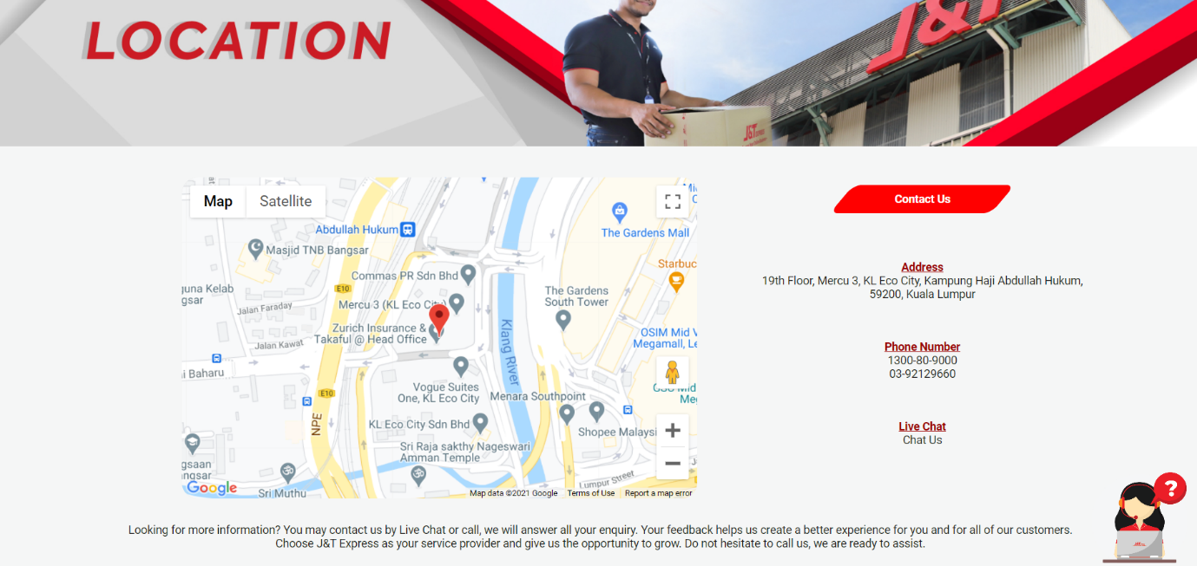

Diagram 2.2.1.7 The “Contact Us” page allowing customers to know where to contact the J&T Express service

#### **Administrator**

11. The system will send the ordering page to staff, where the staff have to confirm the customer’s order before they can pass it to the payment department.

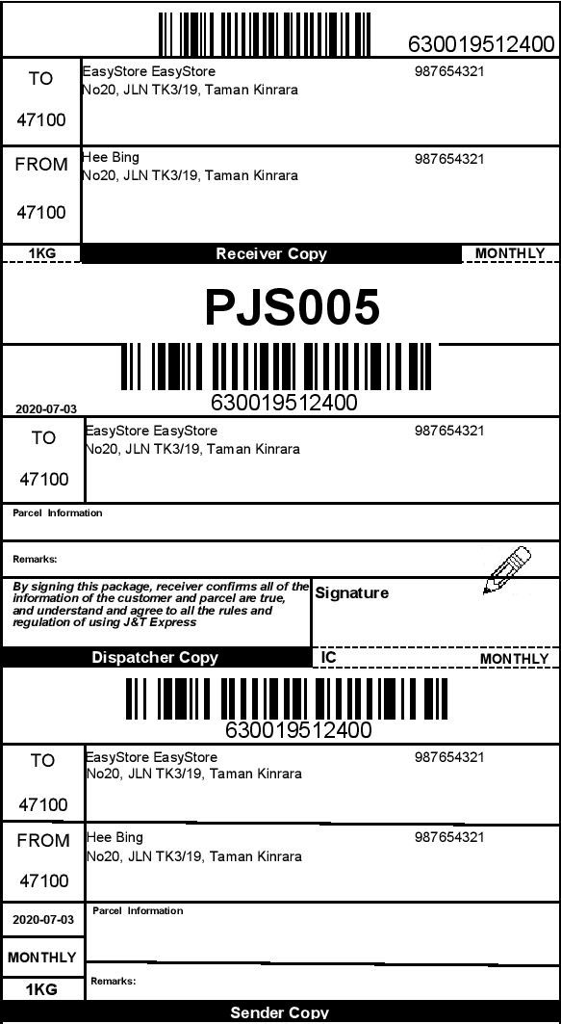

Diagram 2.2.1.8 The order payment screen

12. The system will save all the payments made by the customers so they can check their payment history whenever they want after the customer made the payment.

13. The system should check the delivery items that have been ordered by the customer to ensure that the staff didn’t messed up with other ordered items before they made their checking and pass it to the delivery department.

14. The system will arrange the ordered items by the location for the staff’s convenience in delivering items.

15. The system should collect customer’s feedback so the company can have the opportunity to improve their quality from time to time.

### **2.2.2 Non-Functional requirements**

1. The system should allow the customers to order during 98% of normal working hours and the system will not fail suddenly and without reason. (Reliability)

2. The system can evaluate whether the current system meets the performance and requirements of various aspects through scalability to achieve the maximum workload. (Scalability)

3. The system should be uncomplicated to add code to the existing system so that new functions and mechanisms can be applied to the system at any time. (Maintainability)

4. The use of this system should similar to other systems. For example, login interface (Usability)

5. The system should be able to handle the error to avoid that if the user accidentally cancels or exits the order process, the order made by the user will be undone. (Error-Handling)

6. Only users with the "Customer Advisor" or "Supervisor" role can view customer details, and only users with the "Customer" role can update their own information. (Security)

7. During the order process, the system’s response should not exceed 5 second. (Performance)

8. The data change time must be recorded to the nearest second. (Accuracy Requirements)

9. The system can provide nearly 300 users at the same time to use the "order" function at the same time. (Concurrency Requirements)

10. Portability show it specifies degree to a system element can be well accessed and it could also can interact in two different environments. Besides, it will determine the execution of actions performed by one platform on another platform. (Portability)

11. Maintaining and assuring data accuracy and consistency is the function that can't have the error for a system. (Data integrity)

12. The system must follow a common and standard set of exchange formats to exchange data so that the lack of interoperability when people do not follow standards won’t happen. (Interoperability)

13. Make the system able to process large amount of data and store it safely at the same time. (Capacity)

14. Have a multiple language option so that everyone can use it. For example, English, Chinese, Malay and more. (Accessibility Requirements)

15. The system must have the ability to recover the crash or failure in the system and return to full operation. (Recoverability)

## 2.3 Architectural design

### **2.3.1 Activity Diagram**

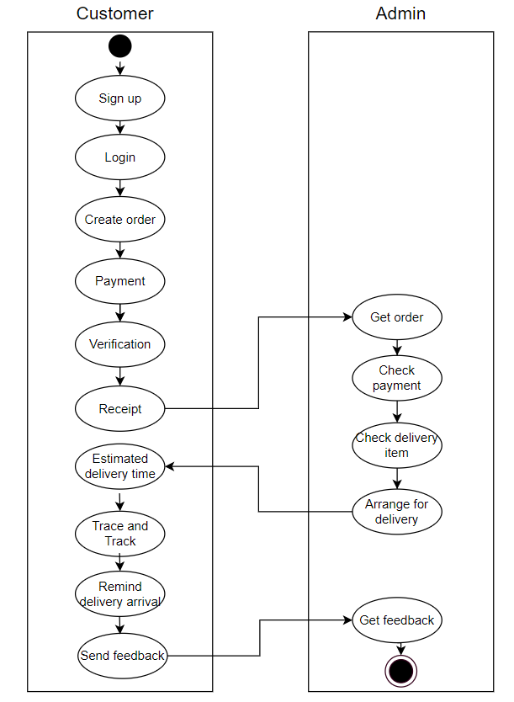

Diagram 2.3.1.1 Activity Diagram

### **2.3.2 Use Case Diagram**

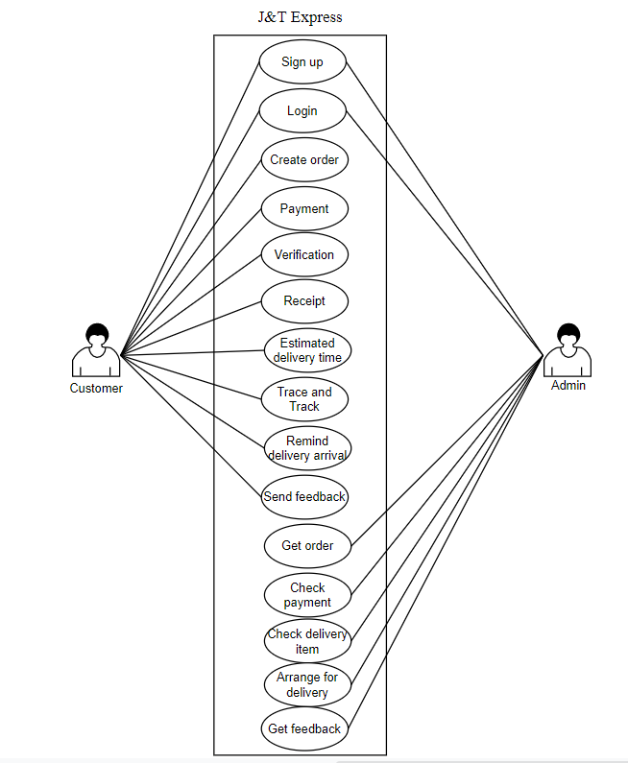

Diagram 2.3.2.1 Use Case Diagram

# **Part 3**

## 3.1 Good user interface design principles

* The UI design must be clarity and be easy to understand

|  |  |
| --- | --- |
|  |  |
|  | |

* The UI design must be emotionally pleasing to look at

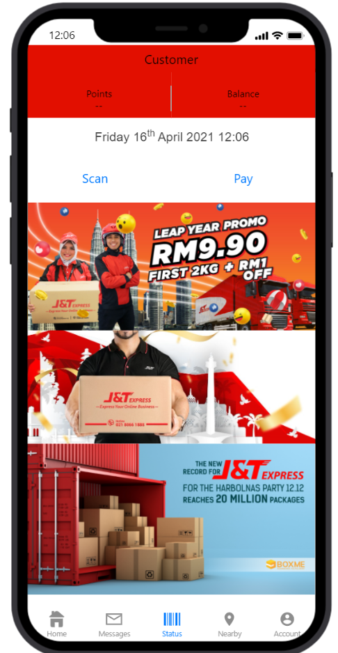

* UI design also need to consistent throughout the site
* User can easy to control of the interface

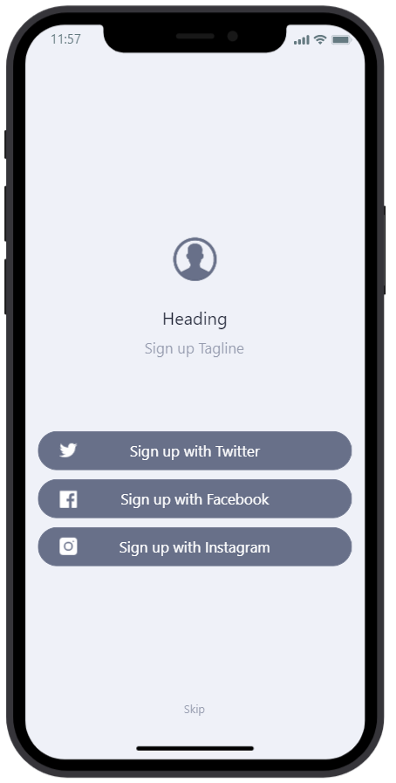

* UI design should match between system and the real world

|  |  |
| --- | --- |
|  |  |

* UI design need to reduce cognitive load

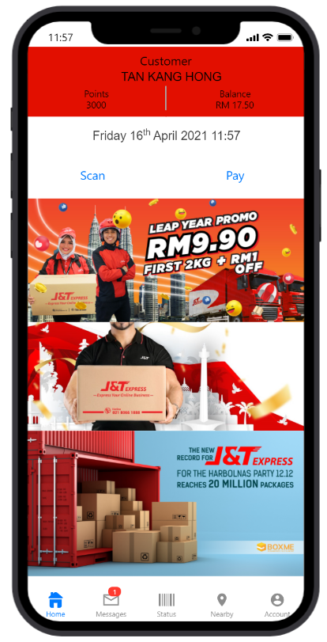

* UI design should prevent error from appearing

|  |  |
| --- | --- |
|  |  |

* UI design also need to test the flexibility and efficiency of use

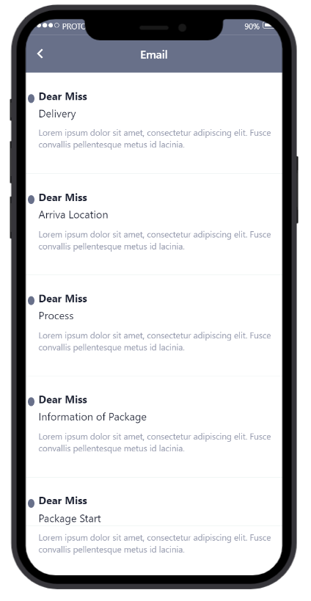

* UI design need to provide help and documentation

|  |  |
| --- | --- |
|  | Inserting image... |

* UI design should cover user families

|  |  |
| --- | --- |
|  |  |

## 3.2 Test cases

1. Login

|  |  |  |  |  |  |
| --- | --- | --- | --- | --- | --- |
| **Test Scenario:** An automated system for checking login verification. A user is required to login with their account in order to access member-only contents in a website. When the user wants to login, the system has to verify the user is able to login with email and password. Based on this, a message will display by the system whether the user has successfully logged in or not. | | | | | |
| **Program Name: Login Validation**  **Prepared by: Tan Kang Hong, Har Chun Wai, Lau Jun Dian**  **Test Date: 01/04/2021** **Tester: Cheng Cai Jie and Nee Mei Yi** | | | | | |
| **No** | **Objective / Test Cases** | **Test Data** | **Expected Results** | **Actual Results** | **Remarks / Comments** |
| 1 | To display error message | Valid password but invalid email | Error message due to invalid email. | - | - |
| 2 | To display error message | Valid email but invalid password | Error message due to invalid password. | - | - |
| 3 | To display message user has successfully logged in | Valid email and valid password | Message user has successfully logged in | - | - |
| 4 | Verify the ‘Remember Me’ functionality | Valid email and password then save it when the user is logged in. | The account will not be logged out automatically for a few days. | - | - |
| 5 | Skip function | Press skip | The users will be redirected to the main page without logging in | - | - |
| 6 | Forgot password function | Press Forgot password | The users will need to verify by system then just can change password. | - | - |

1. Tracking number

|  |  |  |  |  |  |
| --- | --- | --- | --- | --- | --- |
| **Test Scenario:** A parcel tracking system to allow users to check their parcel status. The user will search their parcel by typing the tracking number. Based on this system, user can know their parcel movement anytime. | | | | | |
| **Program Name: Parcel tracking**  **Prepared by: Tan Kang Hong, Har Chun Wai, Lau Jun Dian**  **Test Date: 01/04/2021** **Tester: Cheng Cai Jie and Nee Mei Yi** | | | | | |
| **No** | **Objective / Test Cases** | **Test Data** | **Expected Results** | **Actual Results** | **Remarks / Comments** |
| 1 | Search tracking number | Valid tracking number | Show customers real-time tracking of their parcels | - | - |
| 2 | Get notified for every movement | Click Get notified for every movement | Customers will get notifications when their parcel is arrived | - | - |
| 3 | To display error message | Invalid tracking number | Error message due to invalid tracking number | - | - |

1. Payment

|  |  |  |  |  |  |
| --- | --- | --- | --- | --- | --- |
| **Test Scenario:** A payment system for customers to make their payment. When the customer making the payment will has to verify the payment with the verification code to complete the payment. | | | | | |
| **Program Name: Payment system**  **Prepared by: Tan Kang Hong, Har Chun Wai, Lau Jun Dian**  **Test Date: 01/04/2021** **Tester: Cheng Cai Jie and Nee Mei Yi** | | | | | |
| **No** | **Objective / Test Cases** | **Test Data** | **Expected Results** | **Actual Results** | **Remarks / Comments** |
| 1 | Checking package | Valid order package | Show customer whether the package correctly | - | - |
| 2 | Payment verification | Valid the verification code to payment | Show customer the security code can protect our customer during payment process | - | - |
| 3 | Display estimate delivery date | Valid to know arrive location time | Show customer the package of date will be arrive location | - | - |
| 4 | Cancel payment | Valid order package, and confirmation by customer to cancel payment | Show message that the payment has been successfully cancelled | - | - |
| 5 | Receipt | Valid order package and payment is confirmed | Show customer the receipt to claim the points of J&T Express. | - | - |
| 6 | Point | Valid payments | Customers will get points after their payment has been confirmed. | - | - |

1. Main page

|  |  |  |  |  |  |
| --- | --- | --- | --- | --- | --- |
| **Test Scenario:** Display the main page for the J&T Express app. | | | | | |
| **Program Name: Main page**  **Prepared by: Tan Kang Hong, Har Chun Wai, Lau Jun Dian**  **Test Date: 01/04/2021** **Tester: Cheng Cai Jie and Nee Mei Yi** | | | | | |
| **No** | **Objective / Test Cases** | **Test Data** | **Expected Results** | **Actual Results** | **Remarks / Comments** |
| 1 | Display customer balance | Valid balance | Let customer know their balance left and get reminder from J&T Express when the balance is low | - | - |
| 2 | Display promotions | Valid promotion | Display current promotions so customers can enjoy low shipping price. | - | - |
| 3 | Display email | Valid email | Display the customer’s email in the account page. | - | - |
| 4 | Click payment | Valid payment | Display the checkout screen when the customer wants to make payment | - | - |
| 5 | Display tracking number screen | Valid tracking number | Show customers real-time tracking of their parcels | - | - |
| 6 | Display location screen | Valid location | Show where the branch nearby customer and display all the information of the branch |  |  |

1. Setting

|  |  |  |  |  |  |
| --- | --- | --- | --- | --- | --- |
| **Test Scenario:** An automated system for **testing every function inside setting**. The user is required to check the account information, customer service and other function that are inside the setting page. Based on this, user can know more detail about account information. | | | | | |
| **Program Name: Setting**  **Prepared by: Tan Kang Hong, Har Chun Wai, Lau Jun Dian**  **Test Date: 01/04/2021** **Tester: Cheng Cai Jie and Nee Mei Yi** | | | | | |
| **No** | **Objective / Test Cases** | **Test Data** | **Expected Results** | **Actual Results** | **Remarks / Comments** |
| 1 | Display account information | Account information screen | Show customer all the information details | - | - |
| 2 | Log out | Log out button | The customer will be prompted into the log in screen. | - | - |
| 3 | Change password | Change password button | Let customer change their password | - | - |
| 4 | Block user | Block user button | Display blocked delivery staffs where the staff cannot make deliver parcels to the customer in future deliveries. | - | - |
| 5 | Customer Service | Customer service screen | Show all the company information to customer and display the email address to let customer give some feedback. | - | - |

## 3.3 Software Maintenance

* Corrective maintenance

Corrective maintenance refers to the execution of maintenance tasks to identify, isolate and correct faults so that faulty equipment, machines or systems can be restored to operating conditions within tolerances or limits determined for in-service operation. For example, the maintenance is lifted to fix all the system errors that reported by customers, such as unable to place their order due to technical problems.

When there are too many people using the service at the same time, the service will be interrupted and the maintenance needs to be lifted to restore the interrupted services. As a prevention from constant maintenances, the new systems are needed to be updated regularly to improve the overall system performance and maintainability functions.

* Adaptive maintenance

The system will be modified and updated in terms of its design when the customer needs the system to run on a new environment. For example, the maintenance will be lifted when customer need a new user interface design in the mobile app due to an outdated design.

The web application of the system could sometimes incompatible with some of the web browsers such as Microsoft Edge, Opera etc. Therefore, an adaptive maintenance is conducted to make the web application run smoothly for particular browsers.

* Perfective maintenance

The system will follow customer’s feedback to improve it from time to time. For example, customers need a better data input in the “Create Input” screen. In addition, companies can conduct settlements in a consolidated manner and add new reports to the sales analysis system.

* Preventive maintenance

The maintenance may also be lifted to prevent future problems of the software, and reduce the chance of failure in terms of functionality of the system which are not significant at the moment but may cause serious issues. Preventive maintenance may also reduce the security risks of employees and customers, therefore reducing the risk of litigation and employee compensation, and improve the life expectancy of the equipment.

# **References**

1. J&T Express. #1 Parcel Delivery Services in Malaysia. [online] Available at: <https://www.jtexpress.my/index.php> [Accessed 29 January 2021]

2. Aditi Sharma Kalra (2020). Industry Insider: E-commerce logistics needs talent with holistic industry knowledge, or risk being displaced. [online] Human Resources. Available at: <https://www.humanresourcesonline.net/industry-insider-e-commerce-logistics-needs-talent-with-holistic-industry-knowledge-or-risk-being-displaced> [Accessed 29 January 2021]

3. J&T Express Indonesia. News & Events. [online] Available at: <https://jet.co.id/index/news/news.html?type=News&show=83> [Accessed 29 January 2021]

4. DDC FPO (2017). Top 8 Logistics Challenges Facing the Industry. [online] Logistics Management. Available at: <https://www.logisticsmgmt.com/article/top_8_logistics_challenges_facing_the_industry> [Accessed 29 January 2021]

5. Stfalcon.com (2019). Logistics Software — The Major Key to Solve Your Supply Chain Issues. [online] Medium. Available at: <https://medium.com/swlh/logistics-software-the-major-key-to-solve-your-supply-chain-issues-3fc5ca6fb0a8> [Accessed 29 January 2021]

6. Syndicode Team (2018). 12 software architecture quality attributes and their types. [online] Syndicode. Available at: <https://syndicode.com/blog/12-software-architecture-quality-attributes/> [Accessed 5 February 2021]

7. Software Testing Help (2021). What Are The Quality Attributes? [online] Available at: <https://www.softwaretestinghelp.com/what-are-the-quality-attributes/> [Accessed 5 February 2021]

8. Rajkumar (2020). What are Quality Attributes in Software Architecture. [online] Software Testing Material. Available at: <https://www.softwaretestingmaterial.com/quality-attributes-in-software-architecture/> [Accessed 5 February 2021]

9. Vijay Singh (2020). What is Rapid Application Development Model (RAD)? [online] hackr.io. Available at: <https://hackr.io/blog/rapid-application-development-model> [Accessed 15 February 2021]

10. Guru99. What is RAD Model? Phases, Advantages and Disadvantages. [online] Available at: <https://www.guru99.com/what-is-rad-rapid-software-development-model-advantages-disadvantages.html> [Accessed 15 February 2021]

11. Kissflow (2020). Rapid Application Development (RAD) | Definition, Steps and Benefits. [online] Available at: <https://kissflow.com/rad/rapid-application-development/> [Accessed 15 February 2021]

12. Kissflow (2018). 13 RAD Benefits and Advantages You Could Certainly Expect. [online] Available at: <https://kissflow.com/rad/benefits-of-rapid-application-development/> [Accessed 15 February 2021]

13. Kuldeep Rana (2021). RAD Model - Phases, Advantages & Disadvantages. [online] ArtOfTesting. Available at: https://artoftesting.com/rad-model [Accessed 16 February 2021]

14. Violetta Kornilova. Rapid Application Development Model: definition and stages. [online] The App Solutions. Available at: <https://theappsolutions.com/blog/development/rad-model/> [Accessed 16 February 2021]

15. Hokuapps SEO. Rapid Application Development (RAD) | RAD Phases And Methodology. [online] Hokuapps. Available at: <https://www.hokuapps.com/blogs/rapid-application-development/> [Accessed 16 February 2021]

16. Mukit (2017). 7 Major Functions of Logistics. [online] SCM Wizard. Available at: <https://scmwizard.com/functions-of-logistics/> [Accessed 5 March 2021]

17. Altexsoft (2019). Non-functional Requirements: Examples, Types, Approaches. [online] Available at: <https://www.altexsoft.com/blog/non-functional-requirements/> [Accessed 5 March 2021]

18. Vitaliy Ilyukha. Functional vs Non-Functional Requirements: Ultimate Guide. [online] Available at: <https://jelvix.com/blog/functional-vs-nonfunctional-requirements> [Accessed 5 March 2021]

19. SRS for AakashTechSupport (2014). Non Functional Requirements. [online] Available at: <https://aakashtechsupportdocs.readthedocs.io/en/latest/nonfunc.html> [Accessed 5 March 2021]

20. Ulf Eriksson (2012). Functional vs Non-Functional Requirements - Understand the Difference. [online] Available at: <https://reqtest.com/requirements-blog/functional-vs-non-functional-requirements/#:~:text=What%20are%20those%2C%20and%20how,what%20the%20system%20should%20do.> [Accessed 5 March 2021]

21. Amrit Ray (2016). Good User Interface Design (UI) | Design Principles & User Experience. [online] Available at: <https://www.raydez.com/user-interface-design/> [Accessed 19 March 2021]

21. Jakob Nielsen (2020). 10 Usability Heuristics for User Interface Design. [online] Available at: <https://www.nngroup.com/articles/ten-usability-heuristics/> [Accessed 19 March 2021]

22. Nick Babich (2019). The 4 Golden Rules of UI Design. [online] Available at: <https://xd.adobe.com/ideas/process/ui-design/4-golden-rules-ui-design/> [Accessed 19 March 2021]